

**CS251 – Software Engineering I**

Contents

Instructions [To be removed] 3

Team 3

Document Purpose and Audience 3

System Models 3

System Decomposition 3

Class diagrams 6

Important Algorithm 7

Sequence diagrams 7

Class - Sequence Usage 9

Physical Entity-Relationship Diagram 10

User Interface Design 10

Screen 1 – XXX 11

Screen 2 – YYY 11

Screen 3 – Login Screen (example) 11

Screen 4 – Main Interface (example) 11

Ownership Report 12

Policy Regarding Plagiarism: 13

References 13

Authors 13

# Team

|  |  |  |  |
| --- | --- | --- | --- |
| **ID** | **Name** | **Email** | **Mobile** |
| 20120065 | Ahmed Mahmoud Fahmy | a7med.fahmy94@gmail.com | 01121466814 |
| 20120441 | Hala Mohamed Osman | hala.mohamed199@gmail.com |  |
| 20120282 | Leila Saeed ahmed | leilasaeed2013@gmail.com |  |
|  |  |  |  |
|  |  |  |  |
|  |  |  |  |

# Document Purpose and Audience

This Is the software design document, it's main purpose is to illustrate how the system is structured, what are the main components of the system and how they all interact together

this document is to be previewed by the system designers, developers, and the project manager

# System Models

## System Decomposition (attached as pdf as well)

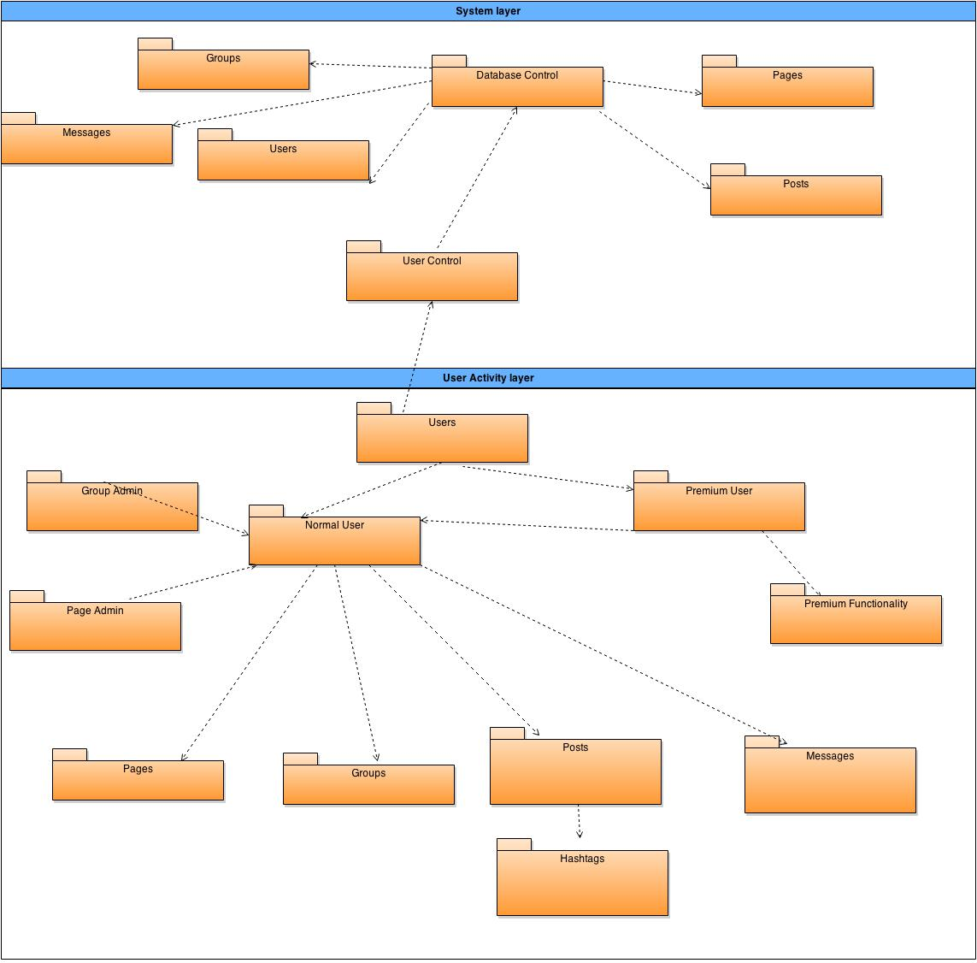

## Class diagrams

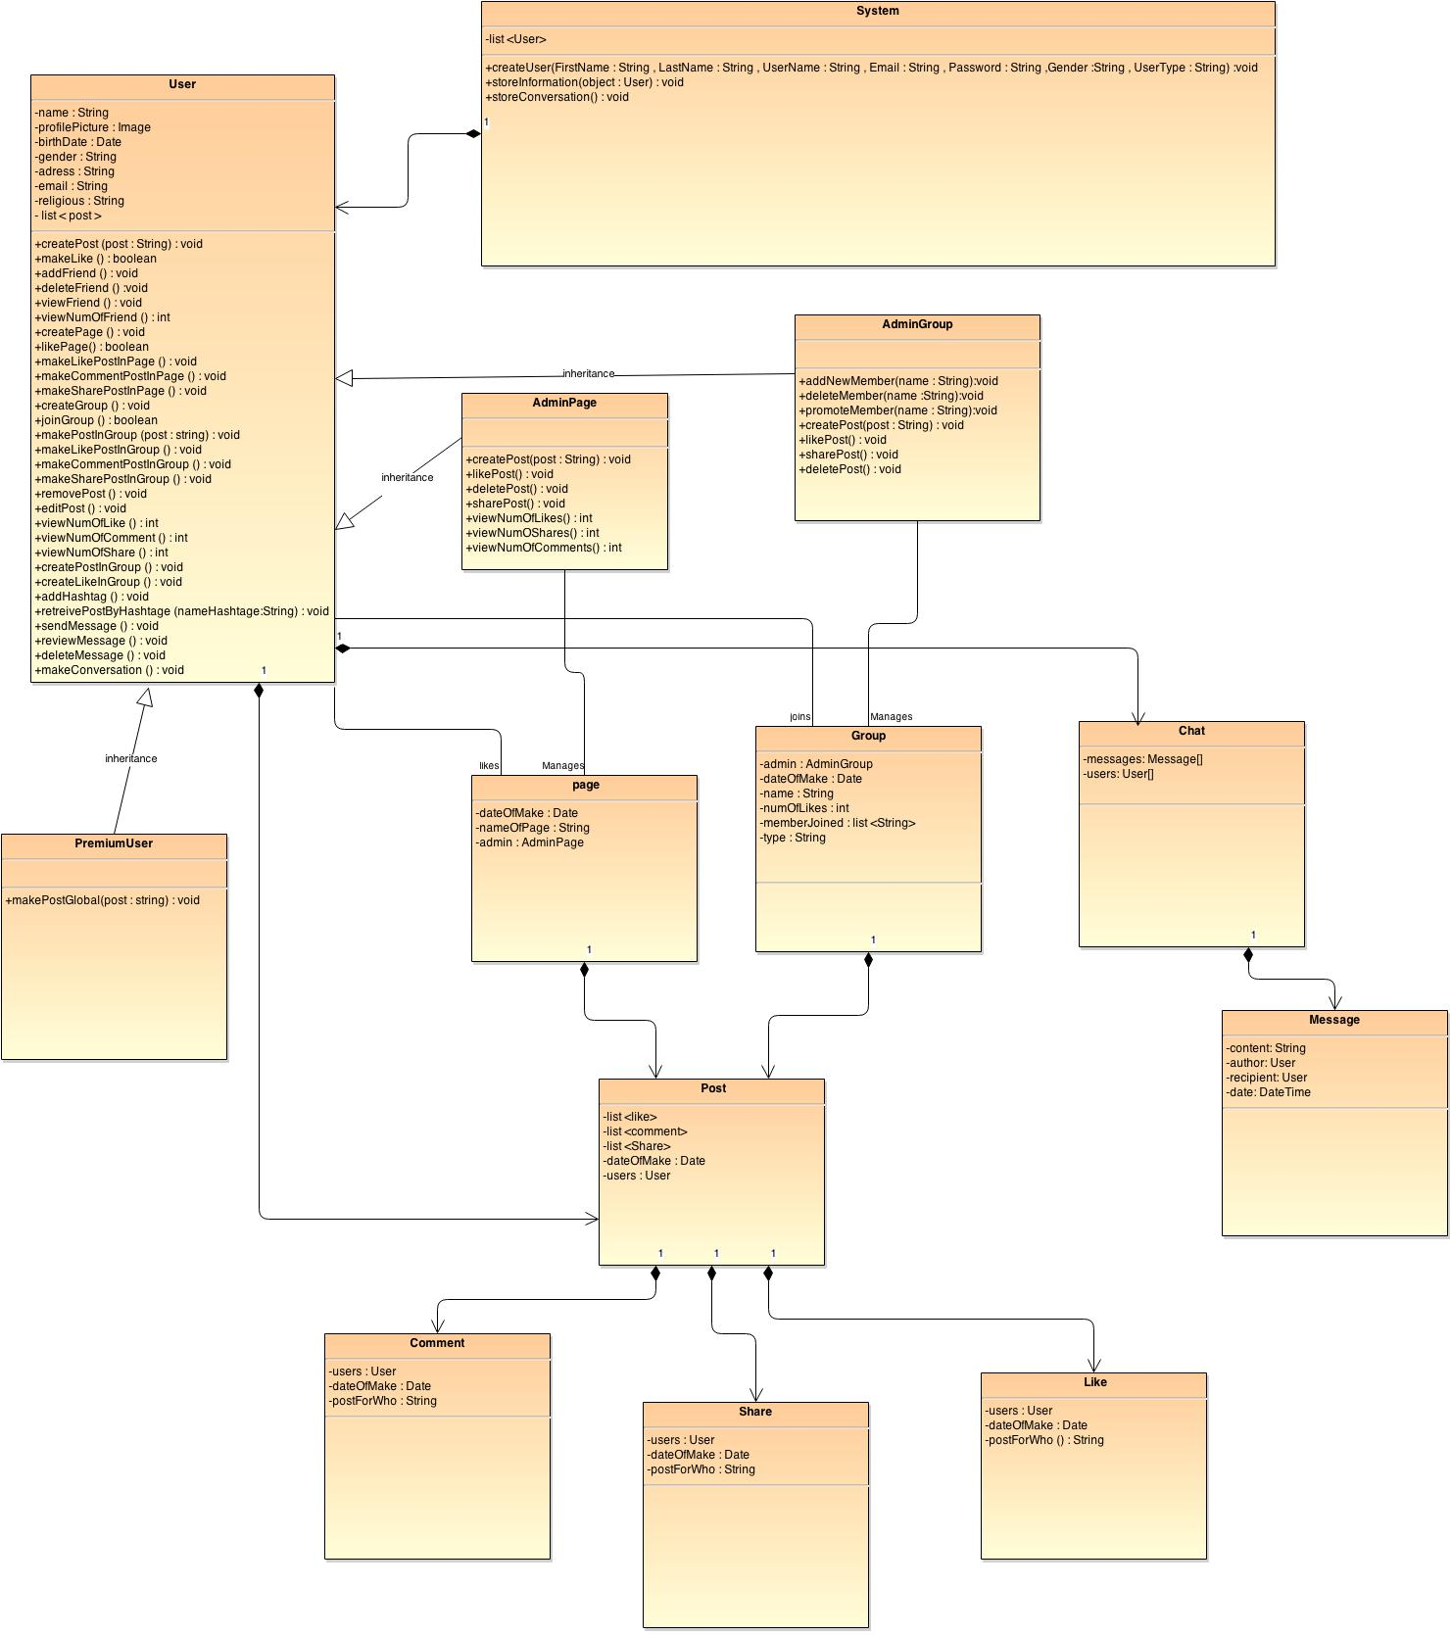

**List down your classes and describe them**

| **Class ID** | **Class Name** | **Subsystem ID** | **Description** |
| --- | --- | --- | --- |
|  |  |  |  |

* **In the above table make sure that each class belongs to a subsystem.**
* **In the above table ALL classes should belong to subsystems. And each subsystem should at least contain one class.**

### Important Algorithm

* **If any method in a class is implementing an algorithm (complex enough), then you should describe it here.**

## Sequence diagrams

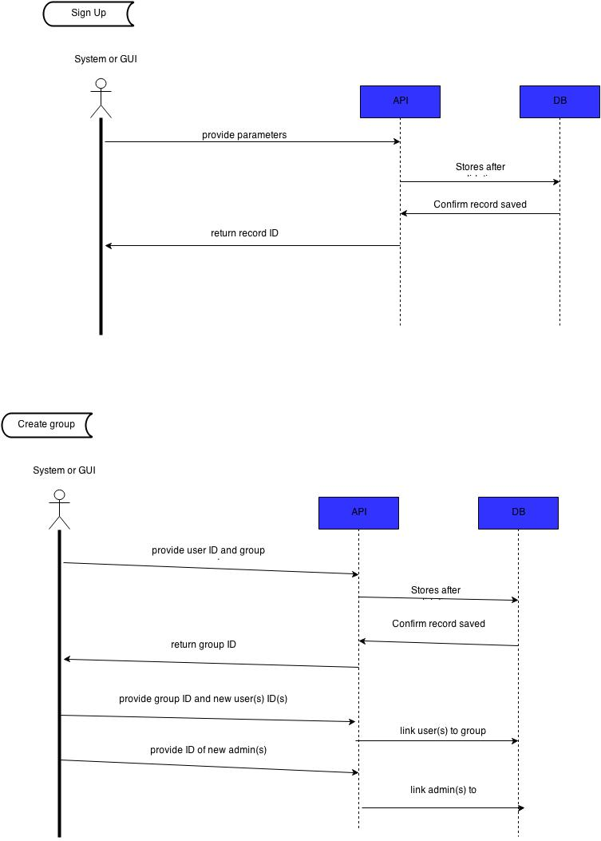

### Class - Sequence Usage

* **In this table, we will list EVERY class in class diagram and which sequences used this class diagram. This helps in avoiding either unused classes or extra classes appears in sequence diagrams. In "Overall used methods" section, put all functions appeared in all sequences. If this table was built in ignorance of actual class / sequence diagrams = REJECTED for whole document.**

| **Class Name** | **Sequence Diagrams** | **Overall used methods** |
| --- | --- | --- |
| E.g. Employee | 1, 3, 5 (means Seq Ids 1, 3, 5 used Employee class) | Save, GetData |
|  |  |  |
|  |  |  |

## Physical Entity-Relationship Diagram

* **Provide the ERD Diagram**
* **convert all entity objects of the class diagram and their relationships into ERD**
* **Don’t list any boundry or control entities!**
* **Following is an example of ERD**

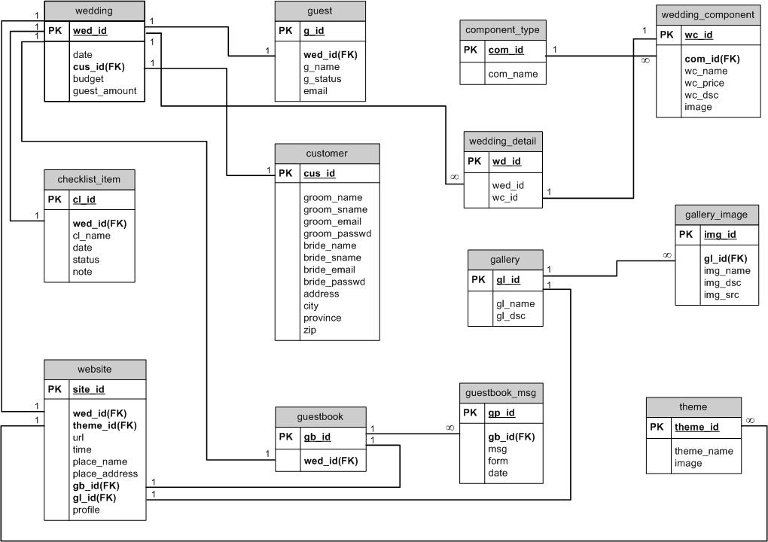

## User Interface Design

### Screen 1 – XXX

### Screen 2 – YYY

### Screen 3 – Login Screen (example)

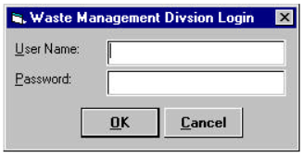

### Screen 4 – Main Interface (example)

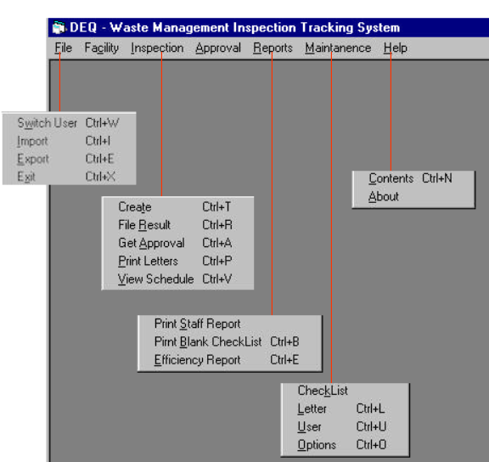

# Ownership Report

* **Remove the following notes and any red notes**
* **For every item in this document, write the owners. If someone is owner of something, s/he understands it 100.%**
* **Team leader must verify the table with the team members.**

|  |  |
| --- | --- |
| **Item** | **Owners** |
|  |  |
|  |  |

# Policy Regarding Plagiarism:

**Students have collective ownership and responsibility of their project. Any violation of academic honesty will have severe consequences and punishment for ALL team members.**

1. تشجع الكلية على مناقشة الأفكار و تبادل المعلومات و مناقشات الطلاب حيث يعتبر هذا جوهريا لعملية تعليمية سليمة
2. ساعد زملاءك على قدر ما تستطيع و حل لهم مشاكلهم فى الكود و لكن تبادل الحلول غير مقبول و يعتبر غشا.
3. أى حل يتشابه مع أى حل آخر بدرجة تقطع بأنهما منقولان من نفس المصدر سيعتبر أن صاحبيهما قد قاما بالغش.
4. قد توجد على النت برامج مشابهة لما نكتبه هنا أى نسخ من على النت يعتبر غشا يحاسب عليه صاحبه.
5. إذا لم تكن متأكدا أن فعلا ما يعد غشا فلتسأل المعيد أو أستاذ المادة.
6. فى حالة ثبوت الغش سيأخذ الطالب سالب درجة المسألة ، و فى حالة تكرار الغش سيرسب الطالب فى المقرر.

# References

* http://www.mhhe.com/engcs/compsci/pressman/graphics/Pressman5sepa/common/cs1/design.pdf

# Authors

* Eng Mostafa Saad